Design Documentation for Hotel Management System

**Prepared by**

*Ajay Patil*

*Abhishek Supsande*

*Mayur Thakane*

*Sanket More*

*Amit Jindam*

**Use - case DIAGRAM**

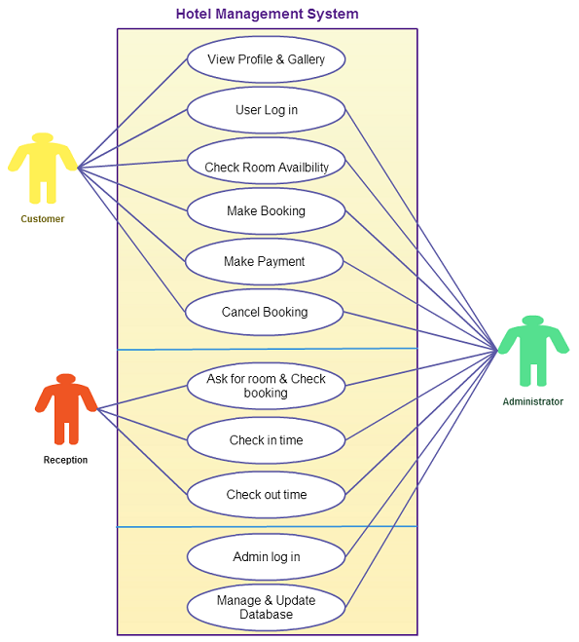

**PROCESS MODEL**

**Waterfall model:-**

Waterfall model method is used in our software development project, this divided into sequential phases where “Each phase must be completed before the next phase can begin”. And this method is used because it shows the flow of project process in logical form. The cost of the project can be estimated once all requirements are gathered and defined.

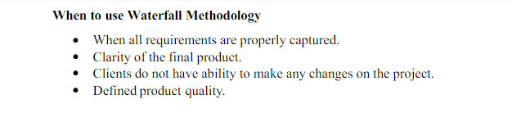

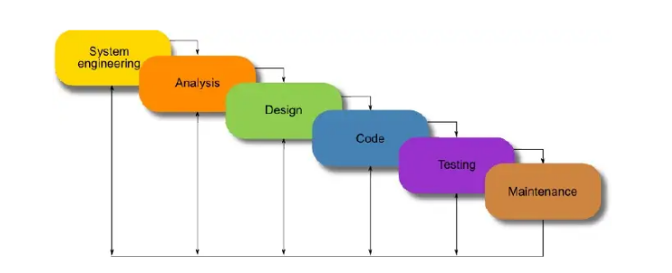

**DATA FLOW DIAGRAM**

